INSTI Rapid HIV Testing
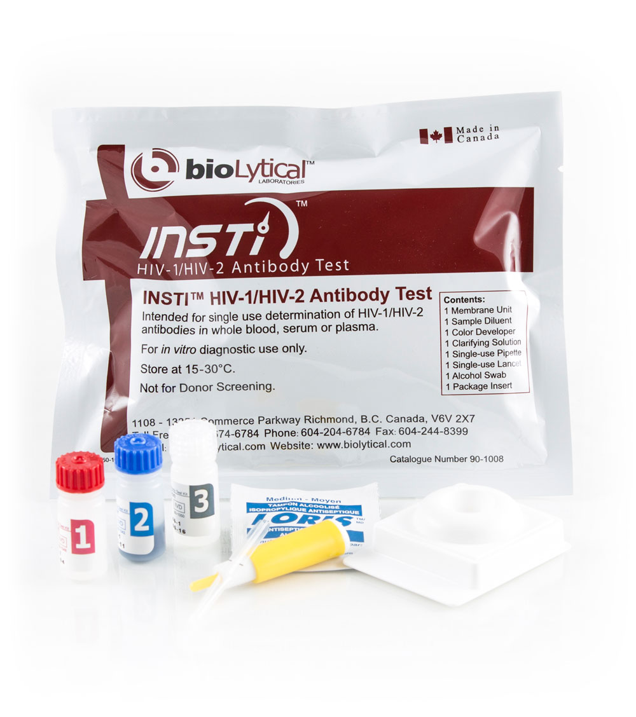
Supplies & Equipment

INSTI Test Kits, Controls Provided
- External Controls

- Testing Devices/equipment
1 membrane unit
3 reagent solutions (Solution 1,2 and 3)
Alcohol Swab
Pipette
Lancet

Additional Supplies, Equipment Required
- Alcohol-based hand sanitizer gel
- Band-Aid
- Red biohazard stick-on bags – available from Safco Dental Supply
- Biohazard sharps container - available from Sam’s Club and CVS.
- Biohazard sign for the fridge
- Timer that makes an audible sound when time is up
- Disposable latex or nitrile gloves
- Disposable, absorbent workspace cover
  - Available from most pet stores
  - Or at Wal‐Mart near Depends.
- Disinfectant wipes
  - Cavi Wipes available from Vitality Medical
  - Different brands also available.
  - Note: to be effective, wipes must be used in accordance with manufacturer’s instructions.
- Sterile Gauze pads
- Regular trash can
- Minimum / Maximum Thermometer
  - To monitor temperature in fridge where controls are stored / room where test kits are stored
  - Min/Max thermometer available from VWR International
- Sharpie (indelible marker) used when running controls, Pen and Paperwork
- Small refrigerator – for controls and specimens only, no food storage
- Watch or clock
- Blank calendar (to explain Window Period)

